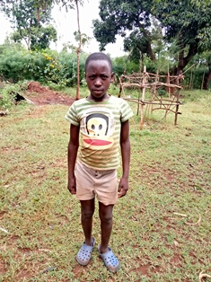

Zera Akinyi
Zera is 10 years old and is in Class four. She is the tom-boy of the group and loves climbing trees and exploring nature. She is the last born in a family of four, and has been in Circle of Hope since she was four years old. Zera is a strong girl who loves helping her single mother with household chores, and is equally helpful if her class. Zera’s dream is to become a successful farmer, and to buy her own truck for ploughing.

