

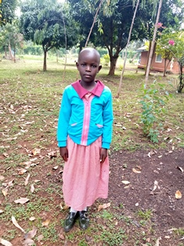

**Yvonne Achieng’**

Yvonne is 10 years old and is in Grade 5 of primary school. Yvonne lives with her grandmother. Her father died when she was five years old, and her teenage mother could not look after her adequately. Grace is very subdued and finds it very difficult to relate with other children her age, and her mother’s absence from her life has made it very difficult for her. She has been part of Circle of Hope for the past five years.