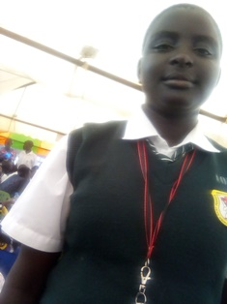

Wendy Jael

Wendy is 17years old, and is a born leader. She is in Form 3 of high school and loves it. She has been leading all the Circle o Hope girls since she joined Mama na Dada fifteen years ago. Because of her leadership skills, she earned a government bursary for her high school education, and has been the Head Girl of her school since she started Form 2 last year. Wendy lives with her mother, having lost her father before she turned one year old. Wendy says that for her sky is not the limit, and she wants to get into politics to make sure that more women are elected into parliament so that they can change the world to become a better place. Wendy is a girl who is not afraid to speak her mind.

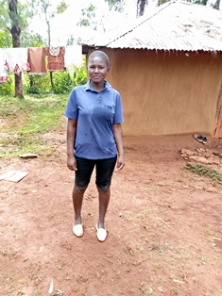
Valery Veronica
Valery is 16 years old, and is in the second year of high school. Valery is the sister to Philly and Movine, and all of them live with their mother who has had struggles with mental illness and has therefore had a difficult time bringing up her children. Valery is a very active member of her school’s debate team, and likes analysing current events, but especially politics. She says she wants to become a politician so that she can make changes in how vulnerable people can be supported by the government.

