

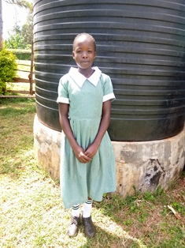

**Velma Atieno**

Velma is 15 years old and is in Grade 8, finishing her primary school in November of 2020. She is a very humble and polite young girl, who loves going to church, and considers herself a God fearing girl. She is the one who always starts and ends the Circle of Hope meetings with a word of prayer. She loves singing and is an active member of her church Sunday School, where she teaches other children the bible and singing. Velma has three brothers and a sister, Zera, and they all live with their parents who are extremely poor due to the mother’s chronic depression. Being the oldest of the five, Velma has had to take a lot of responsibility in helping take care of her siblings, and this is the reason both Velma and Zera were admitted into the Mama na Dada’s Circle of Hope Program to receive assistance. We are hoping that Velma will perform well enough in her primary school exams at the end of the year so that we can help her obtain a government bursary to enable her to go to high school. This would be a big boost for the whole family.