

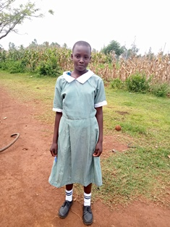

**Ruth Adhiambo**

Ruth is 13 years old. She is in grade 7 of primary school. Ruth would have been one of the girls selected to go to boarding school this year, but she is the one who helps the grandmother mostly emotionally, and it was a difficult decision not to include her because this is the main reason that children in Circle of Hope who are in Grade 7 have been admitted to boarding school, so that they do not have to do the day to day household chores, but concentrate on their studies. Ruth’s mother abandoned her and her three other siblings, and left them with their grandmother. The mother went to look for work in Uganda, and has not been in touch with them for over four years since she left, and nobody knows whether she is still alive or not. Ruth, despite all this, is a very happy girl who loves dancing and entertaining. She is a Sunday School assistant and enjoys supporting her friends in doing Maths and English. She says that when she grows up, she is going to be the best teacher in the world. Her positive energy has been of great help to the grandmother, and we hope that she does not end up resenting being like a mother to her siblings.