

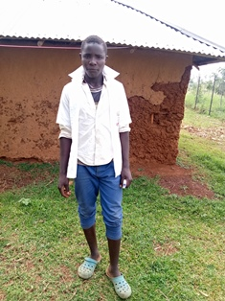

**Raphael Olum**

Raphael is 16 years old. He finished primary school in 2019, but did not perform well enough to join high school, so he has had to repeat Grade 8 this year. Raphael is a very athletic young man, and is the footballer per excellence on the Circle of Hope Group. He follows European football very keenly, and supports Arsenal with all his heart. Raphael has been the captain of the loosely formed Dada Meghan Football club, run by Mama na Dada. In this capacity, he has participated in many regional football tournaments as a player and also a referee in the under 17 football matches. Raphael is a very hardworking and helpful young man who does not shy away from hard work. He is a total orphan and lives with his grandmother, a brother and sister.