

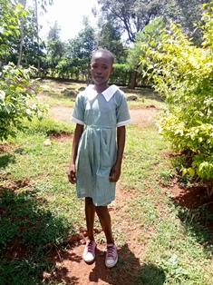

**Rachael Atieno**

Rachael is 13 years old, and is the first born in a family of four. Rachael is in Grade 6. Being the first born, Rachael has learned to be very hardworking, highly organized and determined. She takes care of her siblings as if she were a full grown woman, Despite the huge responsibility she has for her siblings, Rachael still makes time to pursue her singing interest and is a member and a leader of the Sunday School choir at her church. Her organizational capabilities have given her even more responsibility both in church and at Circle of Hope gatherings. She is always in the lead in assisting and guiding other kids to do the right thing. Rachael lives with her father and siblings, having lost her mother when she was only five years old. Rachael actually approached Mama na Dada on her own to request to be included in the program, so she also has a lot of initiative for a young girl.