

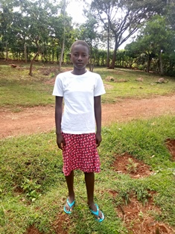

**Philly Achieng’**

Philly is 14 years old and finished primary school in November of 2019, but has not joined high school yet because she did not perform well enough. She is thinking of repeating Grade 8 if she does not get admitted to high school, so that she can do better. Philly is a very humble, determined and hardworking girl who is always there for her friends. She is also very funny and likes entertaining younger children, acting as a clown. Philly has been brought up by her widowed mother, who has struggled a lot to take care of both Philly and her older sister and two younger siblings. Philly dreams of becoming an art teacher, so that she can teach children how to act and sing.