

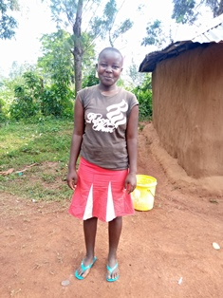

**Movin Christine**

Movin is 17 years old and is in the last year of her high school. She is the older sister of Philly and has been a good mentor to her. Movin describes herself as a God-fearing, respectful and disciplined young girl who is not afraid to speak her mind. She is very active in all sports, especially ball games, in her school, and inspires many young girls to “do the extraordinary”, such as playing football, in which Movin excels and represents her school in the regional games competitions. Movin has been a lead role model in Mama na Dada generally, and has been a part of Circle of Hope Daycare program since she was seven years old. She wants to be a physical education teacher.