

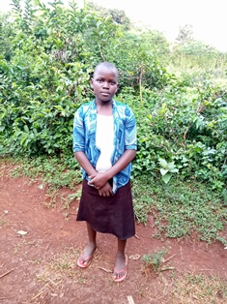

**Michele Achieng’**

Michelle is 12 years old and is in Grade 6 of primary school. She is a funny girl who makes a lot of fun of herself and others. She likes to make fun of her height because she is shorter than most children her age. She loves school and says that this is where she feels the world will change for her. She lives with her grandmother, having lost her father, and her mother was not able to take care of her and the other siblings. Even though she loves to entertain others, she is very serious with her education and spends a lot of her time reading. She says that if she does well enough in high school, she would like to become a doctor.