

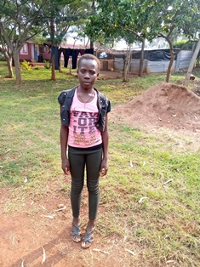

**Maurine Achieng’**

Maurine is 12 years old and is in Grade 6 of primary school. She is the fourth child in a family of five. Morine and her siblings, as well as her mother, live with their maternal grandmother. Her father, who suffered from mental illness, locked the whole family in the whose and wanted to kill all of them, but after the community rescued them, the father killed himself. This has been a very difficult thing for Morine and her family to deal with, and has made Morine very withdrawn and unsure of herself.