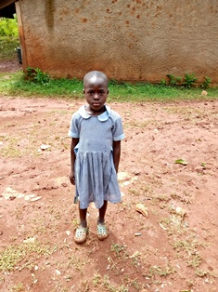
Mary Atieno
Mary is 9 years old, even though, looking at her, one would think she is only four years old. She has been in the Circle of Hope Daycare Program since she was two years old. Mary’s father died when she was only one year old, and she is in Grade 2. Mary has two older siblings and is the last child. Mary is very quiet and withdrawn most of the time, but tries to bond with other children when there are events organized by the organization. From these events, she has come out quite a good dancer, and this makes her really shine when she joins the other children to dace. Mary says she would like to be a farmer to help her mother till their land.

