

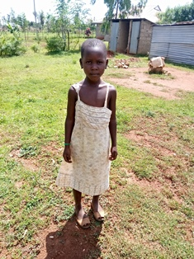

**Joyce Oneko**

Joy, as she is popularly known, is five years old and is in kindergarten. She has been in Mama na Dada’s Daycare program since she was one year old. She is named after Joyce Oneko, the founder of Mama na Dada, because of her mother’s admiration for Joyce. Joy is a very clever and inquisitive girl who likes playing pranks on others, and is not afraid to ask questions. Joy loves fashion and is always seen wearing her mother’s shoes.