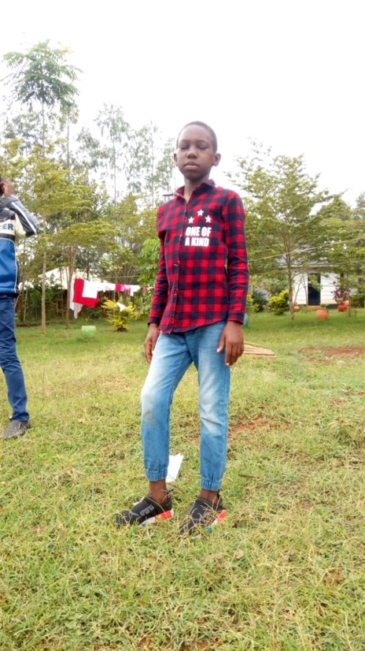
John Barnabas (JB)
Derrick is 16 years old. He has been raised by both his single mother and grandmother. He was born when his mother was barely 16 years old, and the mother returned to school and left him in the care of his grandmother. He has been in Circle of Hope Daycare program since he was five years old. Derrick does very well in school, and when he finished primary school, Mama na Dada helped him obtain government bursary on a yearly rolling basis. He has continued to perform very well in high school and his bursary has been continuing. Derrick loves farming and during school holidays he is always having an agricultural project going on. He rears rabbits and chicken, and is very good with gardening. Derrick wants to be an engineer when he finishes school.

