

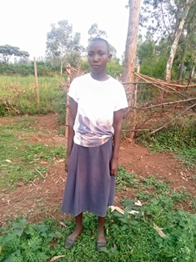

**Jennifer Akinyi**

Jennifer is 17 years old and is one of the Mama na Dada Scholarship girls. Jennifer is a very humble girl, who is always ready to assist younger kids. Jennifer has always performed very well in school, and when she obtained very high marks at the end of her primary school education, she was unable to continue because her father could not pay school fees for her. Jennifer’s mother died when she was young, and she has lived with her father and brothers since. Her father is physically disabled, and her older brother who does menial jobs to support the family, is the one who approached Mama na Dada and sought help to apply for scholarship for her. He believes that if Jennifer gets a good education, it will give the whole family hope. Jennifer loves gardening work, and would like to continue her education up to university level and major in agriculture.