

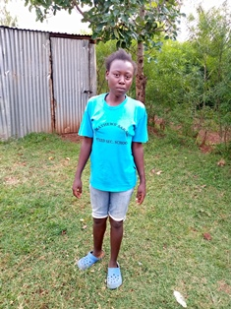

**Idda Achieng’**

Iddah is 18 years old and is in the last year of high school. She is the first born in a family of four, all of whom have been supported by Mama na Dada since the Circle of Hope Daycare program started. Like with many girls in the village, Iddah has worked very hard to help her mother, and even though they are living a very difficult life, they are a happy family. She has been a good role model for other girls, encouraging them not to drop out of school. She guides and directs younger children with a lot of firmness and love. She wants to be a teacher when she finishes school.