

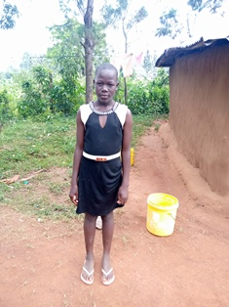

**Emily Awuor**

Emily is 13 years old and is in Grade 7 of primary school. Emily lost both her parents and lives with her grandmother. She is a hardworking girl who enjoys helping her grandmother in tilling her land, and spending time with her friends. She is a happy girl who is very active in the drama club and loves singing, acting and dancing. She says that she wants to be a farmer, but would like to do modern agro-business, using labor saving machinery. She does not want to do subsistence farming the way her grandmother and most of the women in the community do, but would like to do farming in large scale and as a business.