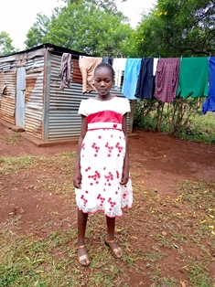
Catherine Atieno
Catherine is 10 years old. She has been in the Circle of Hope Daycare Program since she was two years old. Catherine lives with her grandmother, having lost both her parents. She is the last born in a family of four. Catherine is a happy girl who sings a lot, and likes teaching her peers how to tell stories. Because of this, she is known as “the story-teller”. She wants to be a teacher when she grows up.

