

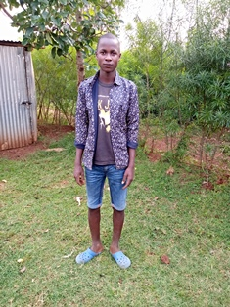

**Calvins Odhiambo**

Calvins is 16 years old and is in the second year of high school. Calvins, together with his siblings, Iddah, Grace and Joy, have been in Circle of Hope since its inception in 2005. Calvin is the second born in this family of four, and is a very hard working young man who takes a lot of pride in being the man of the home since his father died. Calvins is a very good sportsman and loves football. He is a runner and has represented his school in inter-secondary schools competitions. Calvins wants to be a teacher when he finishes school.